## Merchant

Demo date:   
Scoping start date: Nov 6, 2023

MSA Signature Date: Feb 7, 2024  
Onboarding Kick Off Date: Feb 7, 2024

[If Exists] Opt Out Date:  
Go Live Date: Feb 7, 2024

GTM POC: Skoro  
Implementation POC: ArielArjun

ERP: QBO

Tax Integration: Other

### 

### Key people at Merchant

### Accountant:

### CFO:

### Customer service rep who is really involved:

* Account Receivable POC
* Billing POC

### Etc.

### 

| AE/ Implementation Notes Sections [Ops International Team to Ignore]   * Info on how merchant bills   + Spreadsheets related to implementation * Is there any important merchant relationship information?  1) What is the merchant temperament? 2) Is there a key POC: (i.e.: who is the buyer/decision maker?) 3) What are the Tabs features that the key POC cares about? |
| --- |

### 

### Company summary

Technology consulting company offering a sweet of services.

Goals (North star)

What is the merchant's goal? What pain are we solving? Why are they buying Tabs?

* Streamline all consultant usage data into a clean and easy to use billing process

Is there an opt out clause? If so, what is the merchant looking for so they do not exercise it?

* 10/30/2024

### Billing model

* Are there unique things about the customer creation process for this merchant?
  + Nothing unique, generate customers as needed
* Information on how merchant bills
  + Consultants/deliverables have set rates in the contract, but hours are tracked and the customer is billed based on time worked as opposed to the flat rate outlined in the contract. This is due to varying start/end dates, vacation days, or other changes in schedule. The contract is essentially an estimate and serves as a rate card, but is not the end-all-be-all for total cost.
* How contract is broken up
  + Usually, consultant titles are listed along with milestones and/or deliverables. For processing, we are paying attention to billable consulting resources and not milestones (with the exception of a few cases)
* One off things to know about the merchant
  + We are updating our usage template to better serve their use case

### Contract Processing Steps

1. Steps to process
   1. Mostly will be usage for this merchant
   2. Contracts will be sent to contract-ingest, and WILL have key information in the email body.
      1. **Contract Start Date**
         1. They will provide here since there is not a great rule of thumb to estimate start based on contract upload.
      2. **Class**
         1. This is not included in the contract
      3. **Billing Settings**
         1. Hourly rate/T&M contracts: Every 7 days, with a start date on the Monday before the start date, Bill last of period
         2. All others: Monthly, Bill last of period
   3. Contracts will have a list or description of roles that are contracted for. Each of these roles should be its own usage BT.
   4. **Net Payment terms are always found in original MSA for all SOW contracts. PLease reference MSA for that customer if net payment terms are not found in SOW**
   5. Sometimes the role title will be listed in a table (as in the image below in bullet “i”).
   6. Sometimes they will be bulleted in the “Investment” section (image below).

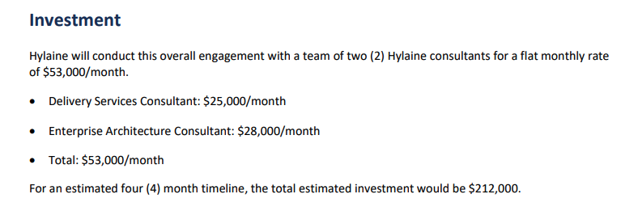

* 1. Sometimes it is found in the body of the statement of work in the “Description of Services” section (image below)

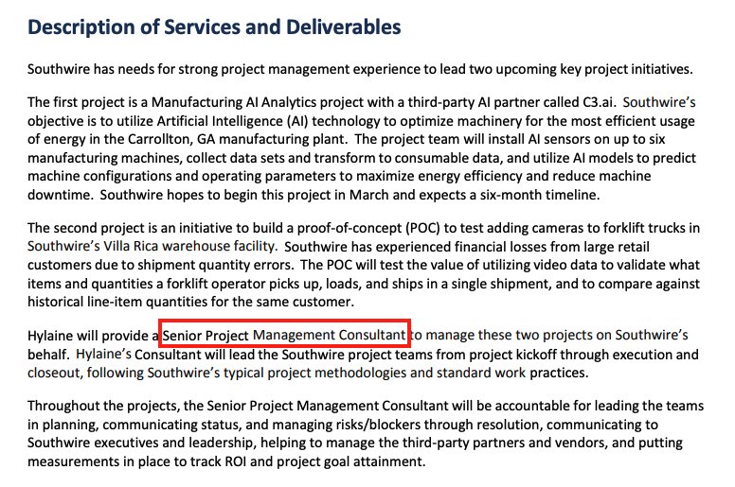

* + 1. If there are multiple consultants with different titles, each will have its own BT
       1. But if there are more than 1 of a specific role listed, only process as 1 BT. In the example below, this would be 2 total billing terms, despite the mention of multiple of the same role.

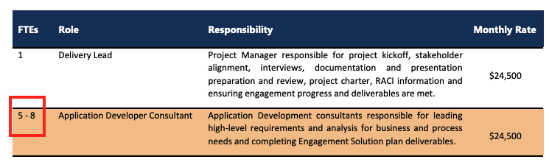

* + 1. Many are monthly rates, but some might be hourly or daily. Regardless, enter that value that cost of the role
  1. BT Detail
     1. Rev schedule:
        1. Start date will be in the email body
        2. Use the total amount of months for the engagement identified in the contract
     2. Name: Name of role
     3. Billing Type: Unit price (this merchant is almost 100% usage based billing)
     4. Integration item: Hours
     5. BT Start date: Should always be the 1st of the month. So if the start date in the email body for the the rev schedule is 7/26, start dates in the BTs should be 7/01
        1. These BTs should be recurring monthly
        2. # of periods: increase by 1 based on the amount of months contracts in order to account for the last month. In the example above:
           1. If it is a 6 month contract, the rev schedule is 7/26/2024 for 6 months, ending 1/26/2025
           2. **The BTs should then run for an extra month**, 7 total periods, ending 1/31/2024 in order to account for billing for the final month of the term.
     6. Frequency: Monthly, unless otherwise specified
        1. Except: Time and Materials should be weekly, starting on the Monday before the Start date.
     7. Event type: Should be the name of the role listed in the contract. If this does not exist, create a new event type if Garage. [Reference this SOP for how to create an event type in Garage](https://docs.google.com/document/d/18beRXfylR8vNPSp3UR_5WcXuZ0zGm_s5BlOrfDiqH7U/edit?usp=sharing).
        1. Event type name: Role title from contract
        2. Merchant: Hylaine
     8. If **“Time and Materials**” is mentioned:
        1. BT name: “Time and Materials”
        2. Event type: Time and Materials
        3. Integration Item: Hours
     9. Do not include “Hazard Fees” or “additional hours” as a BT

1. Amendments
   1. Amendments or change requests might come through as well, these will usually add a new resource or adjust dates for a contract.
2. There is one other one-off use case for Hylaine that is milestone based billing, and this will not be usage.
   1. If milestone based, each milestone will be outlined with a cost and expected completion date.
      1. Each milestone should be its own BT, non-recurring
      2. Invoice date should be the milestone completion date.
      3. BT name is Milestone name
      4. Example of this is below:

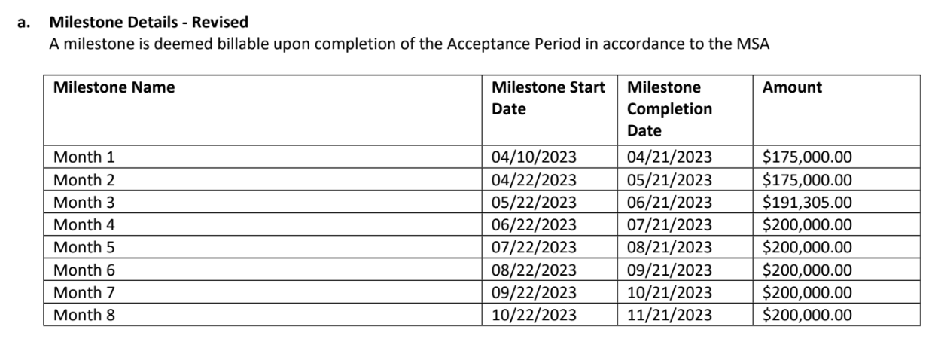

1. Sub-customers
   1. They might have many projects running for a customer at a time. They create each project as a sub-customer.
      1. This will be identified by the title of the document. The name of the sub-customer should be what is after the : in the title. Example is below.
      2. When a new contract comes in, search for a sub-customer with the same name as the SOW on the top of the document before creating a new sub-customer.
      3. **If the mapping is not obvious, DO NOT create a new customer. Please contact ask before generating a new sub-customer**

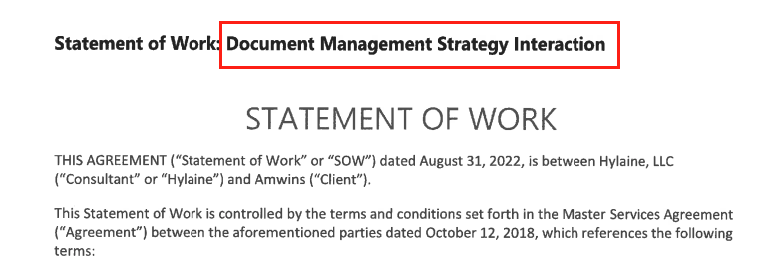

1. Purchase orders
   1. Sometimes, Hylaine will sent through POs for contracts that are already processed. If a PO comes through:
      1. Check to see if a contract is already processed with the same customer and dates as the PO.
         1. If not, please flag to the team
      2. If so, go to the invoices for that contract, and add the PO# number to each invoice for that contract

1. **Customer specific info:**
   1. **Amwins: All roles for all Amwins customers should be “Software Development Consultant” linked to that event type**
   2. **First Citizens Bank: PM Services should be “Project Manager as BT title and Event Type**
2. Anything to ignore in contracts?
   1. Contracts will have details about the project they are carrying out for the customer, potentially detailing milestones/deliverables, or other key information. This information is not important for billing, refer only to the billable consulting resources (except for in the example above for costs are tied to milestones)
3. Default Service Term Start Date (if no info available in the email body; email body supercedes)
   1. 45 days after effective date
4. Default Net Payment Terms
   1. If None, Ops Default is 30
5. Default Billing Frequency
   1. If None Listed, Ops Default is Monthly
6. How do we handle taxes as a line item?
   1. If None Listed, Ops Default is every tax line item becomes a BT

### Events Processing (if necessary)

* Yes, outlined above

Integration Items Processing (if necessary)

* What are the instructions for assigning integration items?
  + Use “Hours” for all usage based
  + Use “Fixed price milestone” for the milestone contracts
  + USe “Time and Materials” for Time and Materials

Post Processing Communications (if necessary)

* Does the Ops Team need to notify anyone on the team re: completion of processing batches in Implementation or Active phase?
  + No

### Customer Information

* Any important information on specifics customers of this merchant
  + None

### Feature Requests

* Split a single BT into separate line items to account for multiple people within the same role
  + We are building this

### Rewatch Calls

* Rewatch by dates